**(Mainnet vs Testnet) & What is metamask? | Metamask Installation**

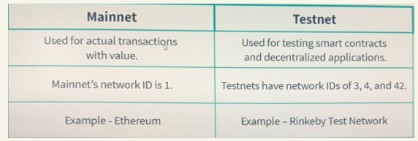

Mainnet and Testnet are two different environments used in the development and testing of blockchain networks. Here are the key differences between Mainnet and Testnet:

1. **Purpose:**
   * **Mainnet:** This is the live or production environment of a blockchain network where actual transactions take place. Real cryptocurrencies are used on the Mainnet, and all transactions are permanent and cannot be reversed.
   * **Testnet:** This is a simulated or testing environment for developers to experiment with and test their blockchain applications without using real cryptocurrencies. Testnets allow developers to identify and fix bugs or issues before deploying their applications on the Mainnet.
2. **Currency:**
   * **Mainnet:** Real, valuable cryptocurrencies are used on the Mainnet. Transactions involve actual tokens or coins that have monetary value.
   * **Testnet:** Cryptocurrencies used on the Testnet have no real-world value. They are often obtained easily and for free through faucets specifically designed for testing purposes.
3. **Security:**
   * **Mainnet:** The security of the Mainnet is of utmost importance since real assets are at stake. The network must be secure against various types of attacks to protect user funds and maintain the integrity of the blockchain.
   * **Testnet:** Security is important, but Testnets are designed to be more permissive and have lower security requirements than Mainnets. This allows developers to experiment without the risk of losing real assets.
4. **Speed and Efficiency:**
   * **Mainnet:** Transactions on the Mainnet are processed in a way that prioritizes security and decentralization. As a result, transactions may take longer to confirm, and fees may be higher.
   * **Testnet:** Testnets often have faster block confirmation times and lower fees, allowing developers to test and iterate more quickly.
5. **Upgrades and Changes:**
   * **Mainnet:** Any changes, upgrades, or modifications to the blockchain protocol need to be thoroughly tested before being implemented on the Mainnet to avoid disruptions and potential security risks.
   * **Testnet:** Developers can experiment with new features, upgrades, or changes on the Testnet without affecting the real Mainnet. This allows them to identify and resolve issues before deploying changes to the production environment.

**Metamask:**

Metamask -> (Store Ether, Send Ether, Receive Ether, Run Dapps, Swap Tokens)

Metamask Installation:

Do the installation on chrome - get started -> set the password -> copy the secret key -> click next and its done

**https://mumbaifaucet.com/**

